Aerospace TB4-axis drive board HY-TB4DV-N Instructions
Thank you for choosing our products better and faster operational numerical control for you, please read this manual
Products Features ：
1：Integrated SCM manual control system, you can directly from the computer manual
2：The maximum 3.5A drive current to a maximum 86 stepper motor drives, more powerful
3：1-16 sub-setting, higher accuracy, smoother operation
4：Overload over-current over-temperature protection, full protection of your computer and peripheral equipment
5：4 files current settings can be set according to the user the actual current requirement
6：Full closed-type optical isolation to protect the user's computer and equipment
7：Professional design, two-stage signal processing, super anti-jamming
8: Bipolar constant current chopper drive motor low-speed non-creeping phenomenon, noise, non-resonant region。
9: 2-way output control, scalable fifth axis or 2-way control of external equipment.
10: Four input control, you can set limit, emergency stop, which is divided into pairs of knives.

Electrical properties (ambient temperature Tj = 25 ℃ pm)：
Input Power |  |  | 12 - 36V DC power supply
Stepper motor drive current |  |  | 3A (peak value 3.5A)
Drive type |  |  | Double-pole constant flow PWM actuation output.
Actuates the electrical machinery |  |  | 42,57,86 step-by-step the electrical machinery, 2 - 4 (4 6 8 step-by-step electrical machinery)
Segmentation set table：
Segmentation set | SW1 | SW2 | Bufferset | SW3 | SW4 | Current set | SW5 | SW6
Full Step | ON | ON | Fast | ON | ON | 100% | ON | ON
Half-step | ON | OFF | 25% | ON | OFF | 75% | ON | OFF
1/8step | OFF | OFF | 50% | OFF | ON | 50% | OFF | ON
1/16step | OFF | ON | Slow | OFF | OFF | 25% | OFF | OFF
Power output interface function
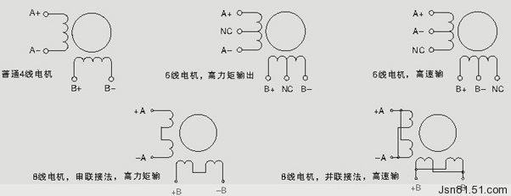
Detailed map interface marked
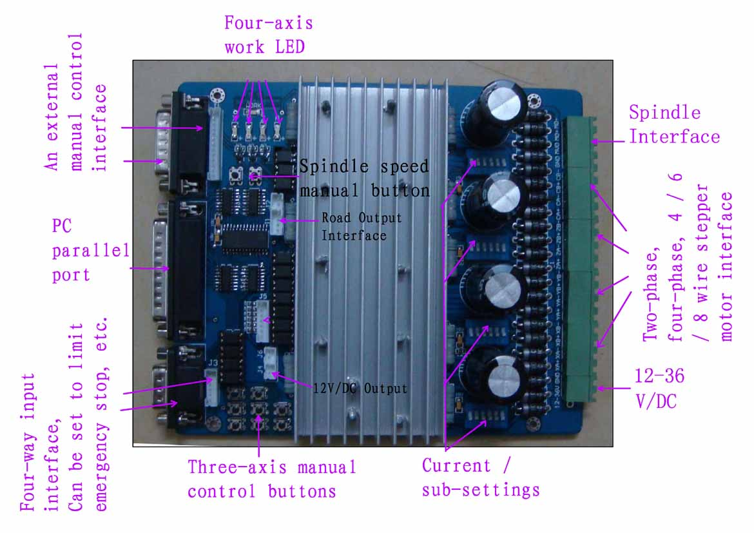
From the computer programmer control over the use of digital
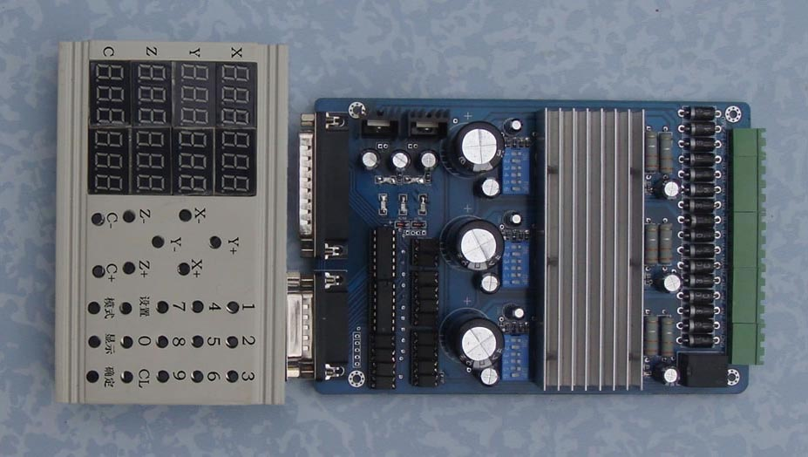
Please note the following before the test items
- To determine the size of the supply voltage and current
- Determine the stepper motor power and current (model)
- Determine the stepper motor wiring
4， Power Please take 12 ~ 36V 8A (stepper motor in accordance with the work of current matching) The above switching power supply, I received a map indicating the power input interface。
12V power output for a 12V cooling fan to pick up where。
The definition of 1-PIN 25 of Parallel Interface is described as follows：
PIN14 | PIN9 | PIN8 | PIN7 | PIN9 | PIN6 | PIN5 | PIN9 | PIN17 | PIN4 | PIN9 | PIN2 | PIN1
spindle motor | X  Empower | X  Dir | X  Step | Y  Empower | Y  Dir | Y  Step | Z  Empower | Z  Dir | Z  Step | C  Empower | C  Dir | C  Step

The definition of 1-PIN15 of Manual Interface is described as follow（Click the image to upper right for the P1 left P15）
P1 | P2 | P3 | P4 | P5 | P6 | P7 | P8 | P9 | P10 | P11 | P12 | P13 | P14 | P15
5V/VDD | Empower | C Dir | Z Step | Empty | Y  Step | Enabled | X  Step | GND | C  Step |  | 5V  vdd | Z  Dir | Y  Dir | X  Dir

Limit Switch Description
Input 1 | Input 2 | Input 3 | Input 4
Corresponding parallel P10 | Corresponding parallel P11 | Corresponding parallel P12 | Corresponding parallel P13

Output Interface Definition：
P1 | P2 | P3 | P4 | P5 | P6 | P7 | P8 | P9 | P10 | P11 | P12 | P13 | P14 | P15 | P16 | P17 | P18 | P19 | P20 | P21
VDD | GND | XA+ | XA- | XB+ | XB- | YA+ | YA- | YB+ | YB- | ZA+ | ZA- | ZB+ | ZB- | CA+ | CA- | CB+ | CB- | MO/V+ | GND | MO  -

Instructions of MACH
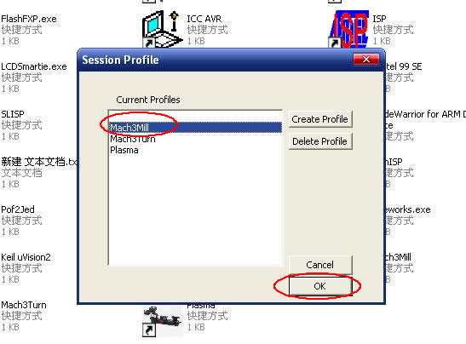
图1
Open MACH3 software, select mach3MILL, and then click OK. Please refer to Fig.1
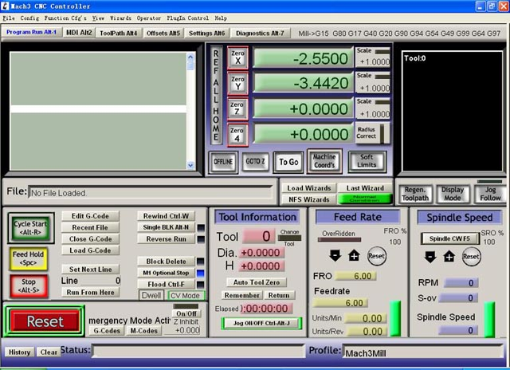
图2

The interface of MACH3 is displayed as Fig.2. The frequently-used action buttons are listed on the interface. We can configure MACH software at first.
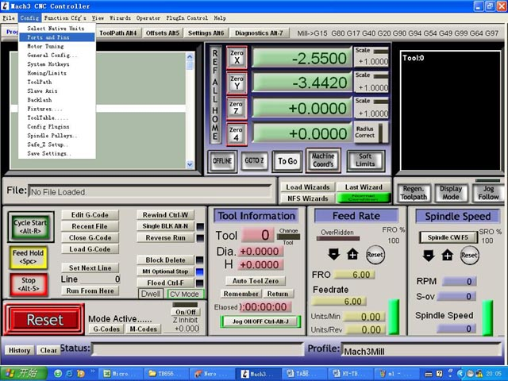。
图3
Click PORT & PIN sub-menu of config menu. Please refer to Fig.3.
Please refer to Fig.4
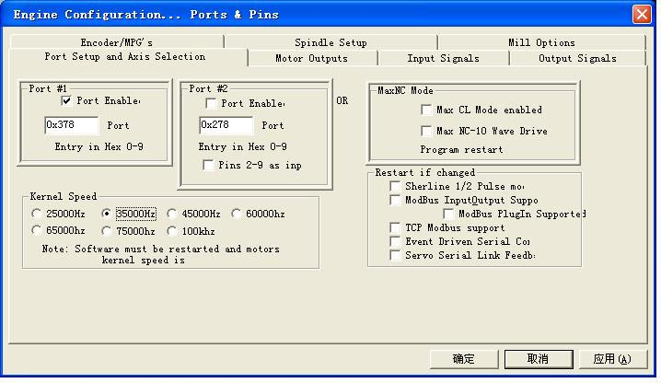
图4

To set up the basic frequency within the above Circle 1. This parameter will affect the rotational speed of the motor. After the setup of basic frequency, select Circle 2 where Configuration Scripting will be defined, please refer to Fig.5.
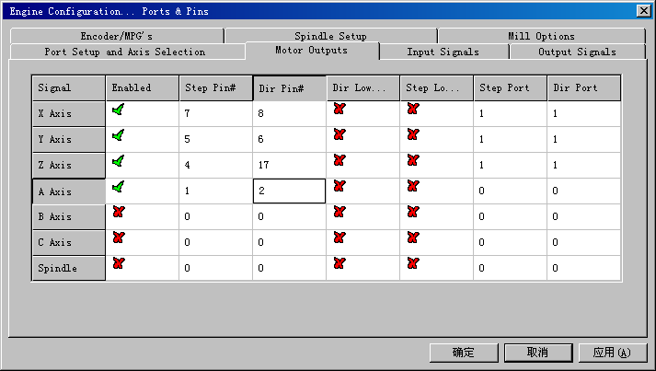

图5

To modify the software settings according to the definition of Parallel Interface which is detailed in the above circle.
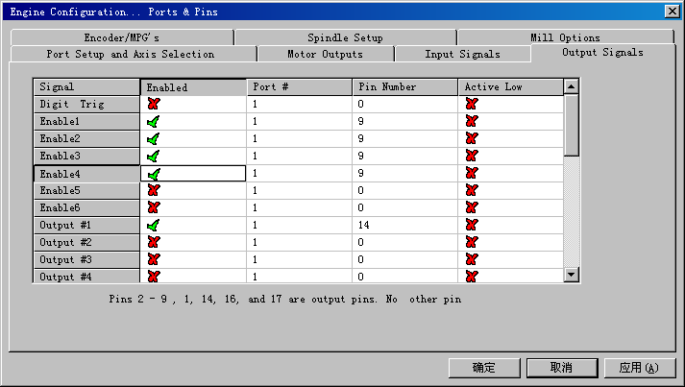
图6
Then select the output signals column, as shown in Fig.6, and set up the corresponding items per the setup described in the circle.
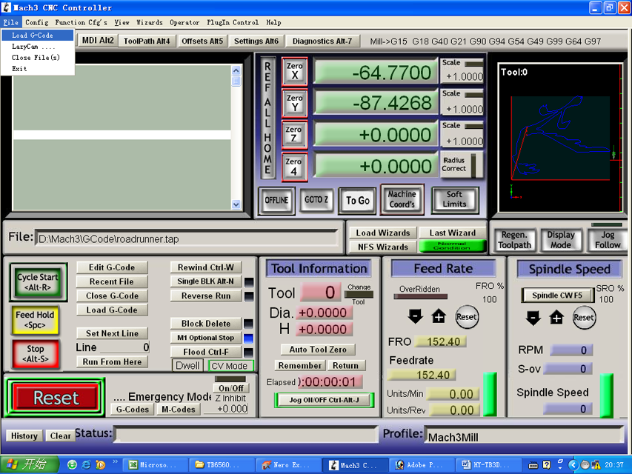
图7
After all have been set up, open the G CODE that needs to run, as shown in Fig.7
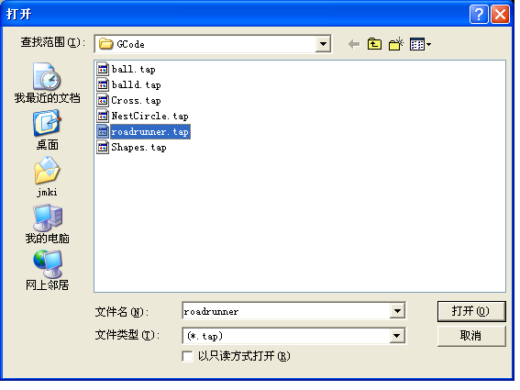
图8

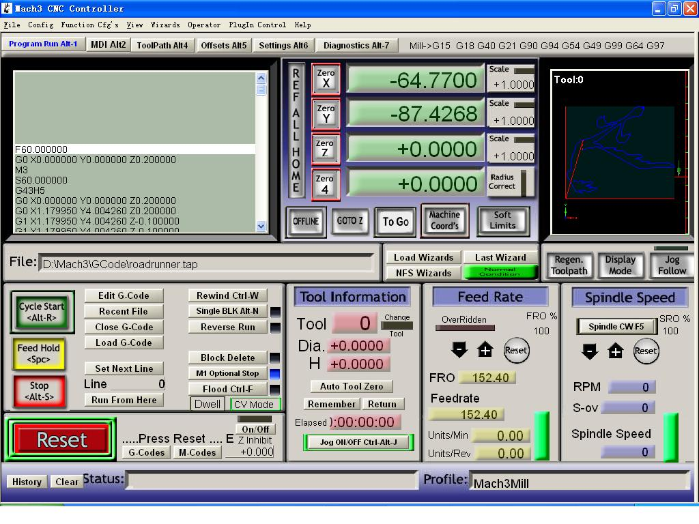
图9
After G CODE has been opened, you may see the red button RESET flashing. Click RESET to stop the flashing and then press CYCLESTART at the location of Circle 2。

Note: If you press TAB on the keyboard, a manual test panel will be displayed.
The limit interface shall be connected with three-axis limit switch. The setting shall be done in output signals column.

